

**SAP Concur Travel QuickStart Guide**

Table of Contents

Updating Your Travel Profile 1

Travel Arranger 2

Booking a Flight 3

Booking a Rental Car 11

Booking a Hotel 13

Updating Your Travel Profile

Use the Travel profile options to set or change your personal Travel preferences and settings. They include:

* Assistant or travel arranger
* Credit card
* Email options
* E-Receipts
* Language
* Password
* Personal preferences (name, address, emergency contact, credit card)
* Regional preferences (number format, date format, language)
* Register for SAP Concur for Mobile
* Travel preferences (air, hotel, car rental, rail preferences)
* Travel vacation reassignment  
  and other preferences and settings (default home page, calendar, emails, accessibility mode)

Traveler Profile Access

**To access your Concur Travel profile information**

1. Click **Profile** > **Profile Settings**.
2. On the **Profile Options** page, select the appropriate **Travel Settings** links on the left side of the page.

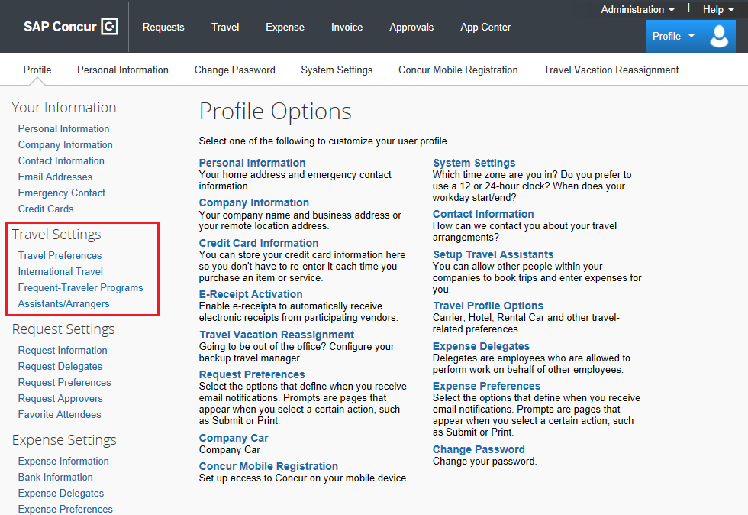

Travel Arranger

To administer travel for another user

1. If you are a travel arranger and you want to change the profile of one of your users, click **Profile**.
2. In the **Administer for another user** field, type the first few letters of the user's name.
3. Select the appropriate user from the search results, and then click **Start Session**.

Booking a Flight

From the SAP Concur homepage, use the Flight  tab to book a flight by itself or with car rental and/or hotel reservations. To book car and hotel reservations ***without*** a flight, use the **Hotel**  and **Car**  **Search** tabs, respectively.

You can access the Flight  tab (or Air / Rail ) by doing the following:

* From the SAP Concur home page, click **Travel** on the menu.
* Click the SAP Concur logo from the left side of the menu.

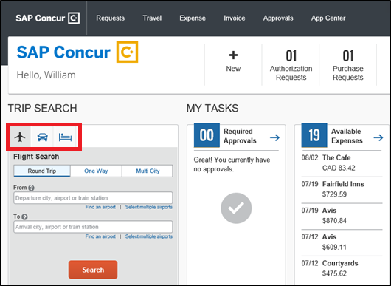

#### Step 1: Start the Search

1. Select one of the following types of flight options:

* Round Trip
* One Way
* Multi City

1. In the **From** and **To** fields, enter the departure and arrival cities for your travel.

When you enter a city, airport name, or airport code, SAP Concur will automatically search for a match.

**Note:** Use the **Find an airport** and **Select multiple airports** links as needed.

1. Click in the **Depart** and **Return** date fields, and then select the appropriate dates from the calendar. Use the remaining fields in this section to define the appropriate time range.
2. Click the  arrow to the right of the time window to see a graphical display of nonstop flights available for the routing and date you have selected. This allows you to adjust your search criteria, and if necessary, to see/reserve nonstop flights.

**Notes:**

* The graphical display is based on flight schedule data. It will not show any rail options, and it cannot take refundability or class of service preferences into account.
* Each green bar represents 30 minutes of time. Place your mouse pointer over a green bar to see all the flights available for that time slot.
* If you change locations or dates, click **refresh graph** for more data.

1. If you need a rental car, click the **Pick-up / Drop-off car at airport** check box.

autocheckbox

* Depending on your organization's configuration, you might be able to automatically reserve a rental car, allowing you to bypass viewing the car search results. When you select this option, additional fields appear. Select a vendor and car type; the car is automatically added to your reservation.
* If you need an off-airport car or have other special requests, you can skip this step and add a car later from your itinerary.

1. If you need a hotel, click the **Find a Hotel** check box.
2. Depending on your organization's configuration, you might be able to specify an airline. If so, the **Specify airline** check box appears.

**Note:** You can only search for one vendor at a time, and this will override the preferred airline searches normally done for all the frequent flyer number carriers.

If you click the **Specify airline** check box, a list of carriers appears that are color coded:

* The first (yellow) are the frequent flyer carriers.
* The second (gray/khaki) are the most requested airlines.
* The remaining airlines are in alphabetical order.

1. Depending on your organization's configuration, you might be able to select the appropriate **Class** of service.
2. From the **Search by** dropdown list, select either **Price** or **Schedule**. (Depending on your organization's configuration, you might not have these options, or you might have an additional option: **Multi-Fare**.)
3. To search only for refundable flights, click the **Refundable only air fares** check box.
4. If necessary, uncheck the **Flight w/ no double connections** check box.
5. Click **Search**.

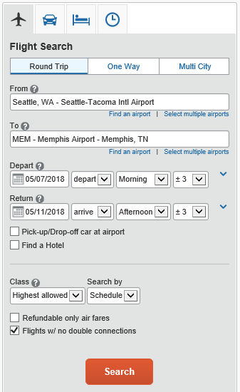

**Step 2: Select a flight**

1. On the **Select Flights** page:
2. If you selected **Price** on the previous page, the **Shop by Fares** tab is initially active. Click either the **Shop by Fares** or **Shop by Schedule** tab for the appropriate flight information.
3. Select the fare button for the flights that you want to purchase.

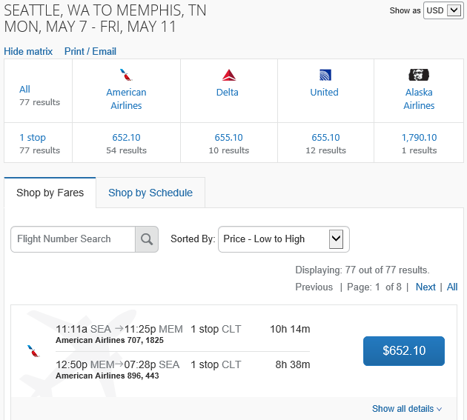

1. If you selected **Schedule** on the previous page, the **Depart** tab is initially active. Select the fare button for the flights that you want to purchase from the **Depart** and **Return** tabs.

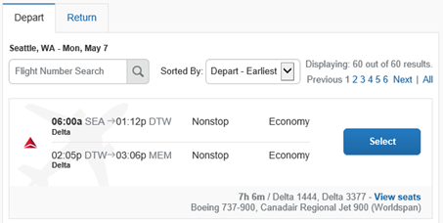

1. Click the **Hide Matrix** link to view additional information on the screen.
2. Review the flight details for your trip.

**Note:** Depending on your airfare provider, you can click the **View seat map** link to select your seat on the flight. Select the appropriate **Available** seat from the **Seat Map**.

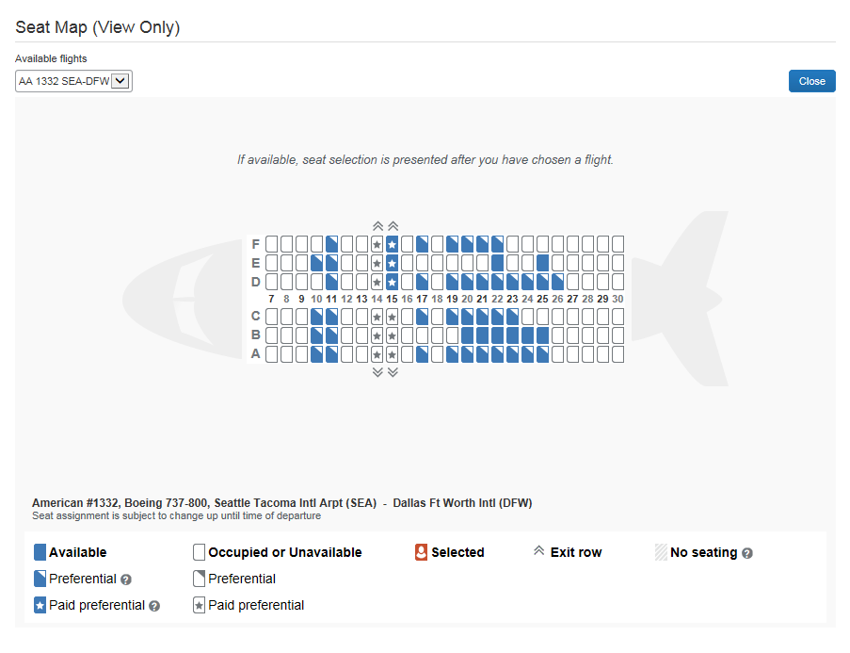

1. On the **Review and Reserve Flight** page you can:

* Review the flight details
* Enter traveler information
* Select frequent flyer programs
* Select your seat assignment
* Review the price summary
* Select your method of payment

1. Click **Reserve Flight and Continue**.

#### Step 3: Select a rental car

If you requested a rental car on the **Flight** tab (or **Air / Rail**) **Search**, the rental car search results appear. For information about booking a rental car, see **Booking a Car** in this document.

#### Step 4: Select a hotel

If you requested a hotel on the **Flight** tab (or **Air / Rail**) **Search**, the hotel search results appear. For information about booking a hotel, see **Booking a Hotel** in this document.

#### Step 5: Review the Travel Details page (itinerary)

Review and change your itinerary, if necessary.

1. In the **Trip Overview** section:
2. Review the information for accuracy.
3. In the **I want to** section, print or email your itinerary as appropriate.
4. In the **Add to your Itinerary** section, add a car, hotel, Wi-Fi, etc., as needed.

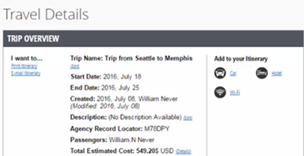

1. In the **Flight** section:
   1. Verify the information for accuracy.
   2. Click **Select Seat** or **Change Seat** to selector change your seat option (depending on the airline).
   3. Your organization might allow you to change or cancel your flight from the itinerary page. If so, click **Change** or **Cancel**, and then follow the prompts to change your outbound or return flight.

Travelers given the option to change a flight will be able to select a different date or time for the trip but must stay on the same airline.

**Note**: Changing a flight can result in fare changes. If this option is available to you, please make sure to check with a World Travel, Inc. Travel Consultant on fare differences.

* 1. If you want to cancel your flight, click **Cancel Air**.

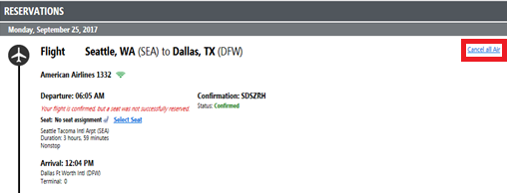

1. Review the remaining sections as necessary and make the appropriate changes.
2. Review the **Total Estimated Cost** section.
3. Click **Next**.

**Step 6: Review the booking information**

1. Use the **Trip Booking Information** page to enter additional information about your trip.

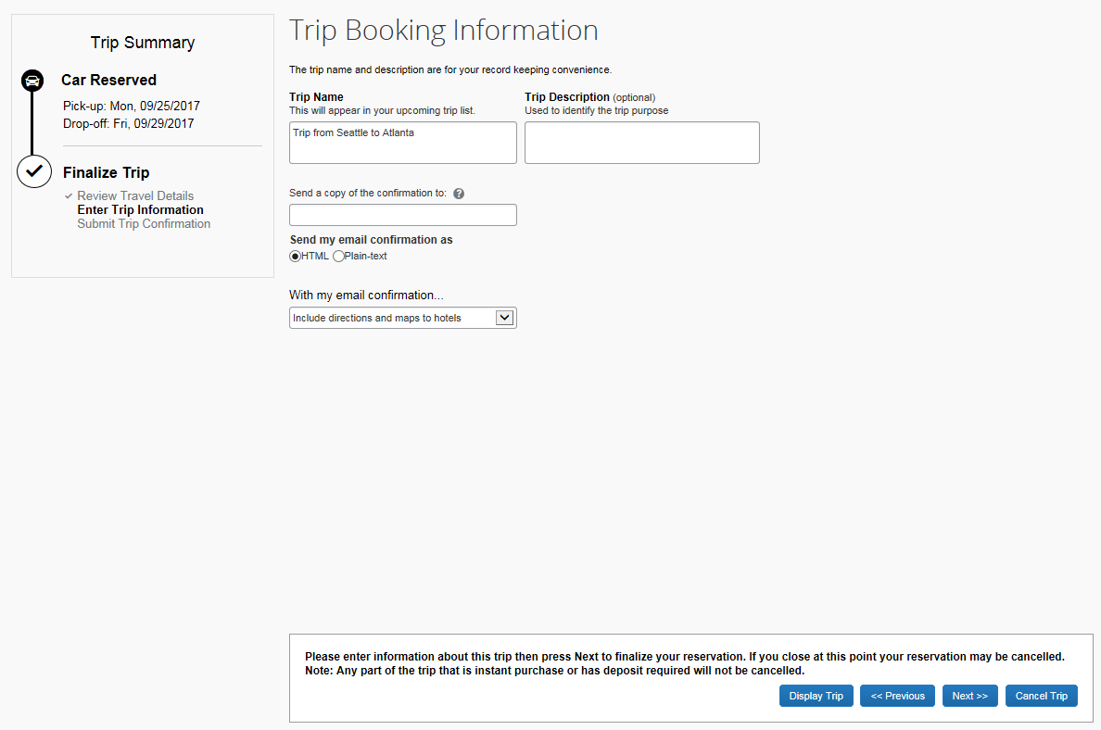

1. Enter or modify your **Trip Name**. This is how the trip will appear on your itinerary and in the automated email from SAP Concur.
2. Enter a **Trip Description** (optional).
3. Indicate if there is anyone else who should receive the initial confirmation email. Enter as many recipients as needed, separated by commas.

* If you book the trip, you will automatically receive the email.
* If you book as an arranger, you will also receive the email.

1. Choose your preferred email format, either plain text or HTML.

Some organizations do not offer travelers this option and always send plain-text email.

1. Depending on your organization’s configuration, you might be able to choose whether you would like to receive directions or maps to the hotel. This information will be part of the initial email from SAP Concur.
2. Depending on your organization’s configuration, your organization may require billing information. If so, make sure to complete this information if requested.

**Note**: Your organization might offer its travelers the option to hold a trip. Travel will always display the length of time this trip can be held on this page. **Pay close attention to the date and time displayed; if the trip is not submitted, approved, and ticketed by the date and time displayed, in most cases it will be automatically cancelled**.

1. Click **Next**.

SAP Concur displays your itinerary on the **Trip Confirmation** page. This itinerary will include any messages about ticketing policies.

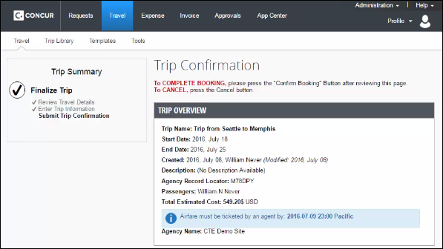

#### Step 7: Purchase the ticket

1. Click **Confirm Booking** to send your request to your manager for approval and World Travel, Inc. Depending on your organization’s configuration, the **Pre-populating Your Expense Report** page appears. You can add transportation expenses for your trip to and from the airport.
2. Click **Finish**.

The **Finished!** screen shows your confirmation number and information to contact World Travel, Inc.

1. Click **Return to Travel Center**.

Booking a Rental Car

#### Step 1: Use the Car tab

If you require a rental car **but not airfare**, request the car using the Car  tab instead of the Flight  (or Air / Rail ) tab.

1. Enter your **Pick-up** and **Drop-off dates** and **times**.
2. In the **Pick-up car at** section, select either:

* **Airport Terminal,** and then type the city or the Airport code
* **Off-Airport,** and then enter (or search for) the location (depending on your organization's configuration, you might be able to have a car delivered to or picked up from your company location).

1. Select the **Return car to another location** checkbox if needed.

Additional fields appear. Choose the appropriate location.

1. To see additional search preferences, click **More Search Options**.
2. Select the **Car Type**.
3. Select smoking or non-smoking.
4. Select the preferred vendors.
5. Click **Search**.

#### Step 2: Filter the results (as needed)

There are two sets of filters: a matrix at the top of the page that you can show or hide, and one on the left side of the page.

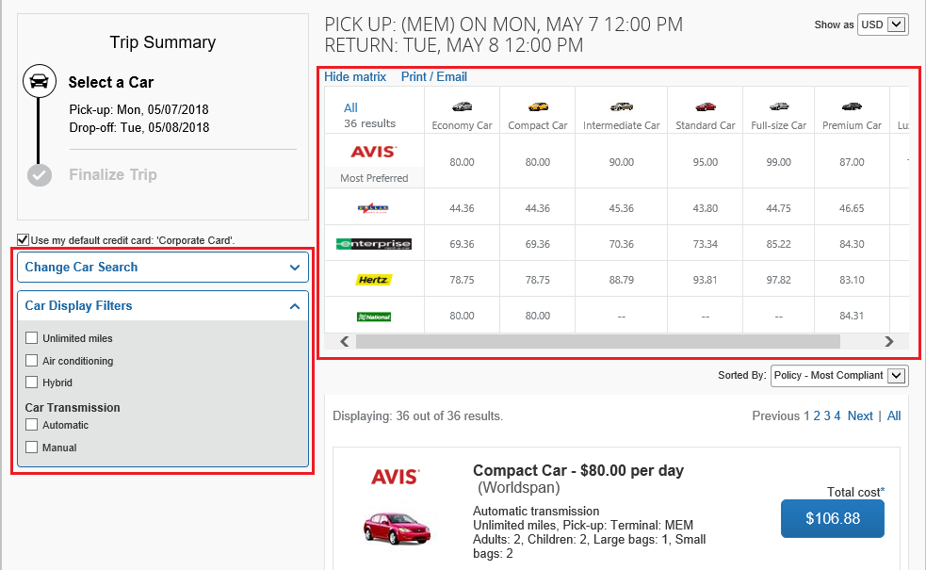

1. Select your filter options from the matrix, and from the **Car Display Filters** section on the left.
2. Select the fare button for the car you want to rent.
3. In the **Review and Reserve** section, select the appropriate options.
4. **Provide Rental Car Preferences**: Enter any necessary information in the **Comments** field and select any additional preferences that you want.
5. **Enter Driver Information**: To add a Rental car Agency Program, click the **Add a Program** link.
6. If you want to change your search, in the **Change Car Search** area:
7. Change your pick-up and drop-off dates and times, and your pick-up and drop-off locations.
8. Expand **More Search Options** to select the car type and vendors that you prefer.
9. Click **Search**.

Travel displays the new results.

1. In the **Travel Details** section:
2. Click the appropriate links to print or e-mail your itinerary and follow the prompts.
3. Click **Change** or **Cancel** if needed, then follow the prompts to change your flight.
4. Click **Next**.
5. Click **Reserve Car and Continue**.
6. On the **Trip Booking Information** page:
7. Enter or modify your **Trip Name**.

This is how the trip will appear on your itinerary and in the automated email from SAP Concur.

1. Enter a **Trip Description** (optional).
2. Indicate if there is anyone else who should receive the initial confirmation email. Enter as many recipients as needed, separated by commas.
3. Click **Next**,
4. On the **Trip Confirmation** page, review your trip details, and then click **Confirm Booking**.

If you trip is not compliant with your organization’s travel policy, a **Travel Policy Violation** window appears. Select the reason for selecting this car, and then explain why.

1. Click **Save**.

Booking a Hotel

#### Step 1: Use the Hotel tab

1. If you require a hotel **but not airfare**, click the Hotel  tab.

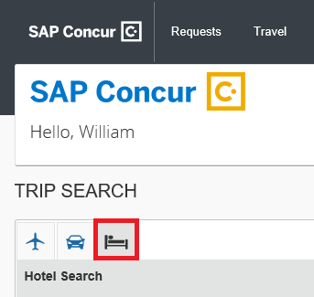

1. Enter the **Check-in** and **Check-out Dates** (or click each field and use the calendar).
2. Enter the search radius.

SAP Concur will always show company preferred hotels within a larger radius, usually 30 miles or kilometers.

1. Choose to search near an airport, an address, company location, or near a reference point / zip code (a city or neighborhood).
2. Enter the reference point or zip code.
3. If you know the name of the hotel you want to stay at, check the **With name containing** check box and then enter the appropriate information.
4. Change your information as necessary.
5. Click **Search**.

**Step 2: Change and filter your search (as needed)**

There is a filter set on the left side of the page. Use show  and hide  arrows, as needed.

1. In the **Change search** area:
2. Change your check-in and check-out dates; change your hotel location.
3. Click **Search**. Travel displays the new results.
4. Use the slider in the **Price** area to narrow your search.
5. In the **Display Settings** area, select the appropriate check boxes.
6. In the **Hotel chain** area, select the appropriate hotels.
7. In the **Hotel Amenities** area, select the appropriate options.

#### Step 3: Review the hotel map (as needed)

1. Review the hotel map.

The red icon shows your reference point.

1. Click any blue "balloon" to see specific hotel information.
2. Use your mouse to zoom and move the map, as needed.

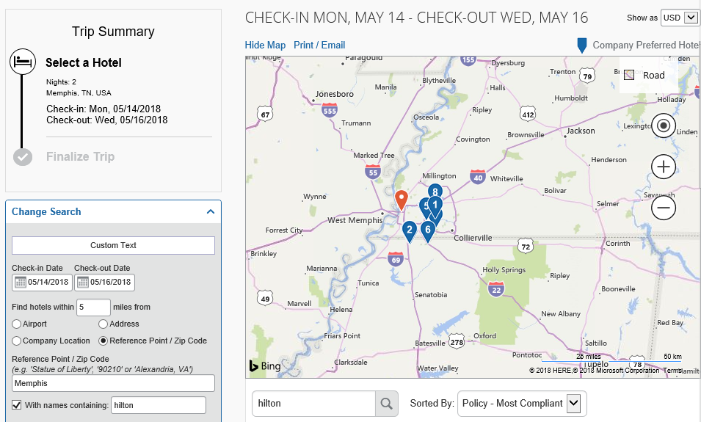

#### Step 4: Sort the search results (as needed)

* Below the map, use the **Sorted By** list to sort the results. Enter hotel names, as needed.

#### Step 5: Review the results

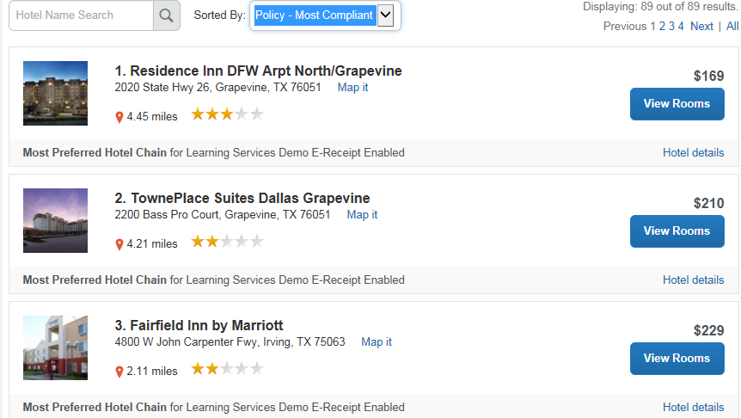

A picture as well as the name, address, rating stars, and price range appears.

1. Click the hotel picture to see more images.
2. Click **Hotel details** to see contact information, street address, cancellation policy, and information about the facility.
3. Click **View Rooms** to see:

* The available room options and rates
* Other amenities per room/rate
* Rules and cancellation policy

#### Step 6: Select the hotel room

1. Click **the Cost button next to the room that you want to reserve**.

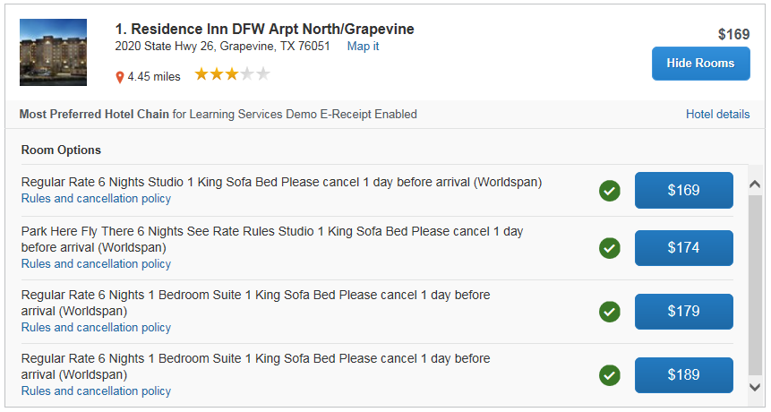

1. The **Review and Reserve Hotel** page appears. Navigate through the page and:

* Review or modify the room preferences.
* Verify or modify the guest and program information.
* Review the price summary.
* Select a method of payment, if available, as defined by your organization's configuration.
* Review and accept the rate details and cancellation policy.

1. Select the **I agree to the hotel’s rate rules, restrictions, and cancellation policy** check box.
2. Click **Reserve Hotel and Continue**.
3. Your **Travel Details** page (itinerary) displays.