**SAP Concur Travel QuickStart Guide**

Table of Contents

Updating Your Travel Profile 1

Travel Arranger 2

Booking a Flight 3

Booking a Rental Car 9

Booking a Hotel 12

Updating Your Travel Profile

Use the Travel profile options to set or change your personal Travel preferences and settings. They include:

* Assistant or travel arranger
* Credit card
* Email options
* E-Receipts
* Language
* Password
* Personal preferences (name, address, emergency contact, credit card)
* Regional preferences (number format, date format, language)
* Register for SAP Concur for Mobile
* Travel preferences (air, hotel, car rental, rail preferences)
* Travel vacation reassignment  
  and other preferences and settings (default home page, calendar, emails, accessibility mode)

Traveler Profile Access

**To access your Concur Travel profile information:**

1. Click the **Profile icon** > **Profile Settings**.
2. On the **Profile Options** page, select the appropriate **Travel Settings** links on the left side of the page.

Travel Arranger

To administer travel for another user

1. If you are a travel arranger and you want to change the profile of one of your users, click the **Profile** icon, then select **Act as Another User**.
2. In the **Act as Another User** box, select the **A Delegate** radio button, and type the first few letters of the user's name.
3. Select the appropriate user from the search results, and then click **Start Session**.

Booking a Flight

From the SAP Concur homepage, use the Air/Rail  tab to book a flight or train by itself or with car rental and/or hotel reservations. To book car and hotel reservations ***without*** a flight, use the **Hotel**  and **Car**  **Search** tabs, respectively.

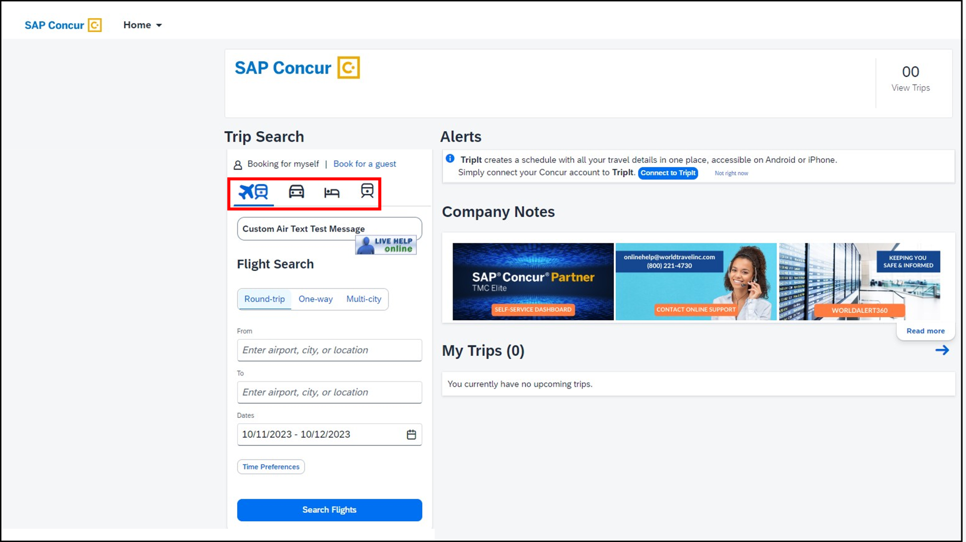

You can also access the Air/Rail  tab by choosing **Travel** from the menu to the right of the SAP Concur logo on the home page.

#### Step 1: Start the Search

1. Select one of the following types of flight options:

* Round Trip
* One Way
* Multi City

1. In the **From** and **To** fields, enter the departure and arrival cities for your travel.

When you enter a city, airport name, or airport code, SAP Concur will automatically search for a match.

1. Choose your departure and return dates using the calendar feature.
2. Click the **Time Preferences** button to select a specific time range for your desired flights.

**Note:** If no specific times are entered, the assumption is *Anytime.*

1. Click **Search Flights** once you have completed the search criteria fields.

**Step 2: Select a Flight**

1. On the **Departing Flights** page:

* Select the **Edit Search** link to update your search criteria if necessary.
* Select the **All Filters** link to filter your results.
* Select the cabin class for the flight that you want to purchase.

* Flight details and a link to view the seat map are shown on the left. All available fare options for the selected cabin class will be displayed. Select the **Fare Details** link to view the onboard experience and product experience for that fare option. Click the **Select Fare** button to make your fare choice.

1. Following the same process, select your return flight from the **Return Flight** display.

1. On the **Review and Book** screen you can:
   * Select your seats.

* + Review the flight details
  + Enter traveler information
  + Select frequent flyer programs
  + Review the price summary
  + Select your method of payment
  + Review baggage allowance details

**Note:** You must check the box indicating that you have read and accept the the airfare rules and restrictions before you can click the **Book and Continue** button.

#### Step 3: Select a rental car

If a rental car is required, click the **Add Rental Car** link on the **Finalize** page. For information about booking a rental car, see **Booking a Car** in this document.

#### Step 4: Select a hotel

If hotel accommodations are required, click the **Add Accommodations** link on the **Finalize** page. For information about booking a hotel, see **Booking a Hotel** in this document.

#### Step 5: Finalize

Review your itinerary.

1. On the **Finalize** page:

* Review the information for accuracy.
* Add hotel and/or rental car reservations if necessary.
* Cancel specific itinerary segments by clicking the **More Actions** link from the segment.

1. In the **Trip Overview** section of the **Finalize** page, enter or modify your **Trip Name**. This is how the trip will appear on your itinerary and in the automated email from SAP Concur.
2. Enter a **Trip Description** (optional).
3. Complete any other required fields that my appear.
4. Click **Confirm** to finalize the booking.

The **Trip Confirmed** appears, letting you know that the booking process is complete. Click the **Back to Homepage** link, or the **View Trip Overview** link as desired.

Booking a Rental Car

#### Step 1: Use the Car tab

If you require a rental car **but not airfare**, request the car using the Car  tab instead of the Air/Rail  tab.

1. Enter your **Pickup** location. You can choose an airport location or enter an off-airport reference point. Enter a **Drop-Off** location (if different from the pickup location).
2. Enter the pickup and drop-off **Dates and Times.**
3. Click **Search**.

#### Step 2: Filter the results (as needed)

1. On the results display, **Filter** and **Sort** the results as desired.

1. Click the **Select** button for the desired vehicle to reserve.
2. On the **Review and Book** page, verify the rental car reservation details for accuracy.
3. Click the **Book and Continue** button to proceed with your reservation.

1. On the **Finalize** page:

* Enter or modify your **Trip Name**.

This is how the trip will appear on your itinerary and in the automated email from SAP Concur.

* Enter a **Trip Description** (optional).
* Using the links on the right, add any other travel segments (if necessary).

1. Click **Confirm** to finalize the reservation. A screenshot of a computer

   Description automatically generated
2. On the **Trip Confirmed** page, use the links to either return to the Concur homepage or see an overview of your entire trip.

Booking a Hotel

#### Step 1: Use the Hoteltab

1. If you require a hotel **but not airfare**, click the Hoteltab.

1. Enter a location. The location can be an airport, a ZIP code, a specific address, or a landmark.
2. Enter the **Check-in** and **Check-out Dates**.
3. Enter the search radius.
4. Click **Search**.

**Step 2: Change and filter your search (as needed)**

On the hotel results display, you can edit your search, as well as filter and sort your search results.

1. Use the **Edit Search** button to change your desired dates and/or location.
2. Click the **All Filters** link to filter your search results.
3. Select the **Sort By** link to choose how you wish your search results to be sorted.

#### Step 3: Review the hotel map (as needed)

From the list of hotels, hover your mouse pointer over a hotel property option on the left to see the highlighted location on the map on the right. You can also hover over a plot point with a nightly rate on the map to highlight that hotel on the list on the left.

The blue pin on the map represents your reference point.

#### Step 4: Choose the hotel

For each hotel option, a picture as well as the property name, star rating, address, general amenities, and minimum price appears.

Click **View Rooms** to select the desired hotel.

At the top of the hotel property page, you will find images of the property (if available), as well as a list of services and amenities offered.

#### Step 6:

#### Select the hotel room

Each room rate category will provide a brief description of the room, along with the cancellation policy and approximate total for the entire stay (excluding taxes and fees).

1. Click the **Select** button to choose the desired room category.

1. On the **Review and Book** page, verify the hotel room reservation details for accuracy. Navigate through the page and:

* Verify or modify the guest and program information.
* Review or modify the room preferences.
* Review the accommodation cost.
* Select a method of payment, if available, as defined by your organization's configuration.
* Review the rate details and cancellation policy.

1. Check the box indicating that you have read and understand the **Rate Rules and Restrictions**.
2. Click the **Book and Continue**.

1. On the **Finalize** page:
2. Enter or modify your **Trip Name**.

This is how the trip will appear on your itinerary and in the automated email from SAP Concur.

1. Enter a **Trip Description** (optional).
2. Using the links on the right, add any other travel segments (if necessary).
3. Click **Confirm** to finalize the reservation.

1. On the **Trip Confirmed** page, use the links to either return to the Concur homepage or see an overview of your entire trip.

